Dear Parent,
Garbanzo is an online platform for learning Spanish that our classroom will be utilizing for both in-class learning and for out-of-school review and homework.
I have chosen this tool because it shares the same Comprehension-Based, Acquisition-Driven, Proficiency-Oriented vision for language learning that is held by our department. Garbanzo lessons are interactive, combining informational and narrative texts with challenge questions that are designed to mimic the experience that your student has in the classroom with me. I am confident that Garbanzo is the best way to support your child’s journey to Proficiency, and I am excited for them to learn and explore history, geography, classic stories, culture, and more through Garbanzo lessons.
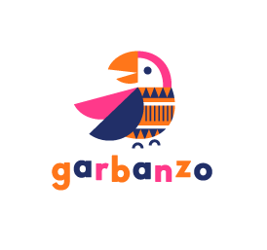
Your child’s class will be creating accounts within the next few weeks. Here’s what you need to know:
- Garbanzo is FREE for your child.
- The Garbanzo website is a secure environment, built to the highest standards of online child safety. It is fully COPPA compliant, requesting limited user information at signup that is NEVER shared with third parties.
- If your child is under the age of 13: Parents and guardians of minors will receive an email verification from noreply@mg.garbanzo.io. Please read the notice and click to “Activate” your child’s account.
- If your child is 13 or older: Parental verification is not required for accounts of students over the age of 13. Your child will complete the signup process entirely on their own.
Please reach out directly to me with any questions you may have about Garbanzo and the website’s use in my class.
Thank you,

